Whitney Williams Jones
School of Dance
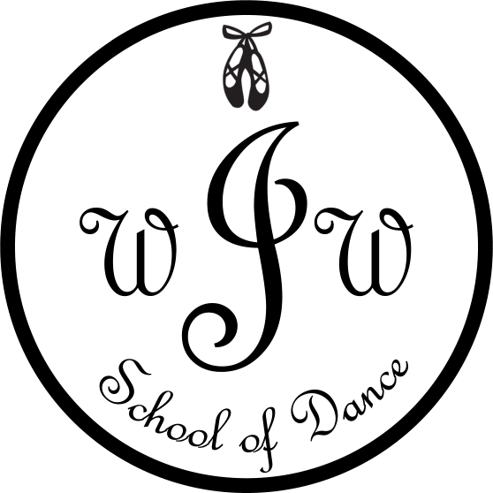

Studio Handbook
979-240-6712

About Whitney Williams Jones School of Dance
Whitney Williams Jones School of Dance is a recreational dance school where students will receive a high quality dance education in a non competitive, yet disciplined and fun atmosphere. Students who participate in our classes build confidence, improve coordination, increase their knowledge of dance technique and have fun! At the end of the year we will present a formal recital where all students will have the opportunity to perform routines they have learned in class.

Class Descriptions

Tutu Class:
(Mommy and Me 18 months old-2 years old) Whitney Williams Jones School of Dance plans to engage your little one through creativity, movement, and music as well as give them an introduction to ballet. We know that all of these aspects encourage brain and motor skills development that will only serve them well in life when it comes to coordination and imagination. We would love to have both girls and boys in this class since all great stories include princes and princesses! A Caregiver will attend class and facilitate the teacher with instruction to the dancers.
Class attire: leotard, tights, ballet shoes. (This class will not participate in recital.)

Combination Classes:
(3 years old- 2nd Grade) Ballet and Tap - The fundamental ballet and tap movements and technique will be learned in these classes.
Class attire: black leotard, pink tights, pink ballet and black tap shoes. (Ballet skirts and dance shorts are allowed.)

(Intermediate- 3rd Grade-4th Grade) Ballet/Lyrical, Jazz, and Tap- Dancers will learn intermediate tap, ballet/lyrical and jazz technique and skills.
Class attire: black leotard, tan tights, pink ballet, black tap and black jazz shoes. (Ballet skirts and dance shorts are allowed.)

(Advanced 5th Grade-12th Grade) Ballet/Lyrical, Jazz, and Tap- Dancers will learn advanced tap, ballet/lyrical and jazz technique and skills.
Class attire: black leotard or form fitting dance top, tan tights, pink ballet, black tap and black jazz shoes. (Ballet skirts, dance shorts and pants are allowed.)
*** Jazz Elite- An audition only dance team for dancers in grades 3rd- 8th. Dancers will grow from students into performers in the competition setting. Ask about more information regarding auditions via email or in person.
Advanced Ballet and Pointe I/II Advanced ballet techniques, movements, and combinations will be learned in this class.
Class attire: black leotard, pink tights, pink ballet shoes. (Ballet skirts are allowed.)
All dancers will need to wear their hair up and out of their face. No jewelry will be allowed.

Fees

- A registration fee of $35 per student/$55 per family, along with a recital fee of $50 per student/$60 per family, is due at the time of registration and is non-refundable.

- Tuition is calculated on a yearly basis, so even if the number of weeks in a month varies, tuition remains the same for the entire year (September-May). Tuition each month will be $55 per student with a discount of 10% for each additional sibling excluding Jazz Elite and Ballet/Pointe classes.

- Tuition may be paid by the 1st dance class of each month without penalty. Any tuition not paid for by the 1st dance class of the month will incur a $10 late fee at the time of payment. If tuition becomes more than 2 months late, the student may come to class to observe, but not participate until tuition payments are current. If tuition is more than 2 months late the student will not be allowed to attend Whitney Williams Jones School of Dance for the rest of the year. A returned check fee of $35 will be charged in the event of a returned check. Once a check is returned, payments can only be made by cash or credit card.

- Tuition payments can be made to Mrs. Jones by cash, check or credit card. All fees to be settled before or on May 15, 2018.

- A non-refundable costume deposit will be due by October 15th. This deposit will be $40 per costume for the recital. Costumes will be ordered in November to assure that they will arrive in time for the recital. A remaining costume balance will be due February 15th if taxes, shipping and handling, or total amount of costume exceeds the costume balance paid in October.

ALL TUITION IS DUE AT THE 1ST CLASS OF EVERY MONTH PAYABLE BY CHECK, CASH, DEBIT OR CREDIT CARD. 10 % DISCOUNT IF ANNUAL TUITION IS PAID IN FULL BY OCTOBER 15TH.

Calendar of Dates
Week of September 11th | Classes Begin
Week of October 2nd | Fall Visitors Week
November 20-24th | Studio Closed for Thanksgiving Break
December 11&12th | Class Christmas Parties
December 18-January 7th | Studio Closed for Christmas Break
Week of January 8th | Classes Resume
March 12-16th | Closed for Spring Break
Week of April 2nd | Spring Visitors Week
Week of May 14th | Last Class Days
Thursday May 17th | Run Thru at Keye Ingram Auditorium
Saturday May 19th | Dress Rehearsal Keye Ingram Auditorium
Sunday May 20th | Dance Recital Keye Ingram Auditorium

Policies
- Parents are expected to pick up students at the end of class time. Teachers are not responsible for students after their scheduled class time. If an emergency arises that hinders a parent from picking up a dancer on time please call to let us know. If a student is not picked up at the end of class time a babysitting fee of $20 will be charged and a fee of a dollar a minute after the first 5 minutes that the student is still at the studio.

- Students are expected to be respectful to their teacher and fellow students during their classes. Inappropriate behavior will be discussed in a conference with the student.

- Regular attendance is very important to your child’s growth as a dancer, however if a class is missed, it can be made-up by attending another class prearranged by the dancer and Mrs. Jones.

- Whitney Williams Jones School of Dance reserves the right to dismiss any student or parent who disrupts the learning atmosphere at the studio or is disrespectful to any teacher, fellow parents, or fellow students.

- Whitney Williams Jones School of Dance will send out frequent emails and notes in your child’s class. Please ask questions at any time you do not understand something. Communication is important.

- Whitney Williams Jones School of Dance will occasionally post pictures of classes and students on our website and Facebook page.

Safety

- Gum is not allowed in the studio. The only drink allowed is water in a container with with a lid.

- Dangling jewelry is not allowed during class due to the safety of the student.

- Running is not allowed in the studio, especially in tap shoes.

- Whitney Williams Jones School of Dance does not provide medical insurance for its students.

- Whitney Williams Jones School of Dance is not liable for any injuries sustained at the studio. If an injury occurs, parents or guardians are responsible for the financial coverage of medical expenses.

Contact Information
Please email Whitney Jones at whitney@wwjdance.com

